Ex-1 ex-2 ex-3 ex-4 ex-5 Ex-6 ex-7

HTML TABLE TAG QUESTIONS

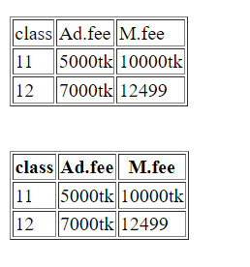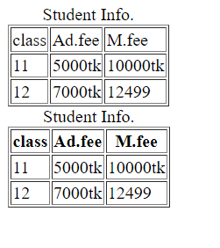 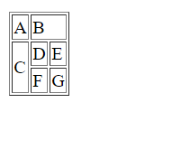 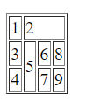 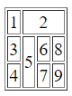 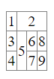 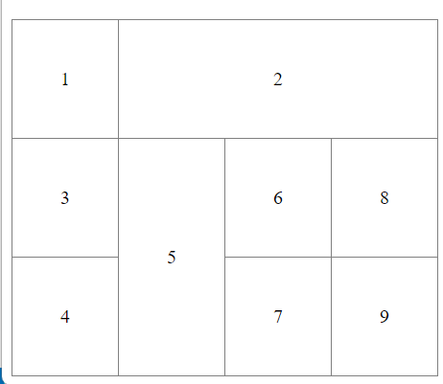

ex-8 Ex-9 ex-10

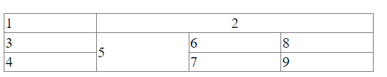 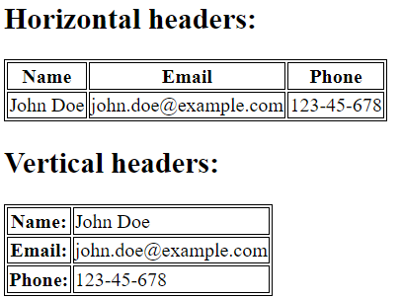 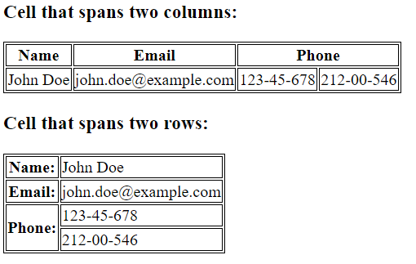

Ex-11 ex-12

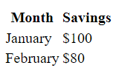 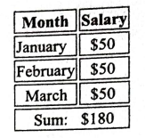



**Board questions:**

|  |  |  |
| --- | --- | --- |
|  |  |  |

|  |  |
| --- | --- |
|  |  |
|  |  |

